1. Go to Build page : http://wwwin-nccm.cisco.com/builds/view/BPA and check only for BPA dolphin or chipmunk. Do not use the develop. Copy the link by right click on download option :

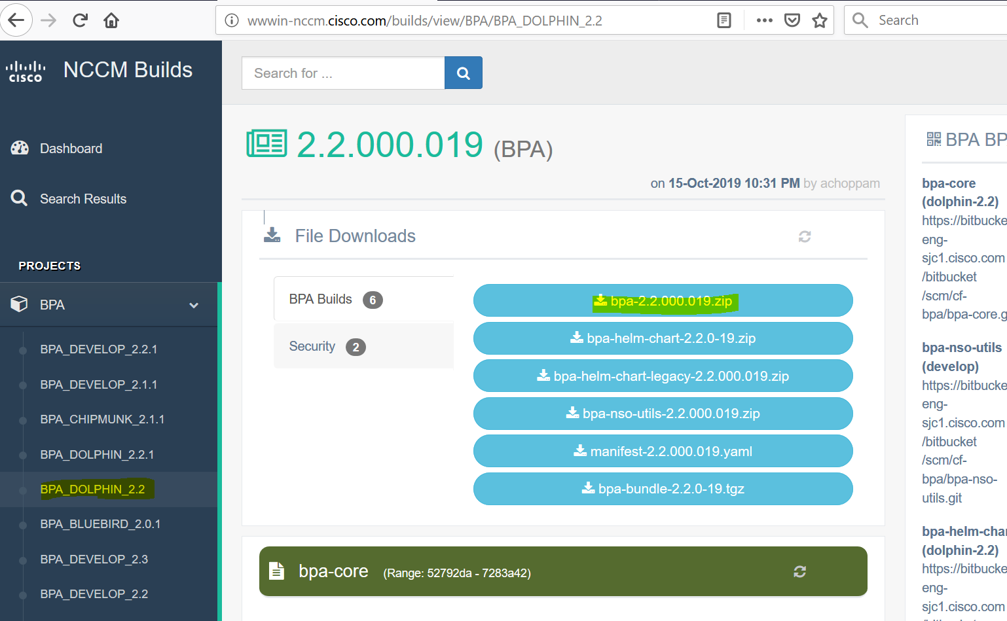

1. Enter the below command in order to Shut down docker containers :

docker ps -a | grep -v CONTAINER | awk '{print $1}' | while read id ; do docker stop $id; docker rm $id ; done

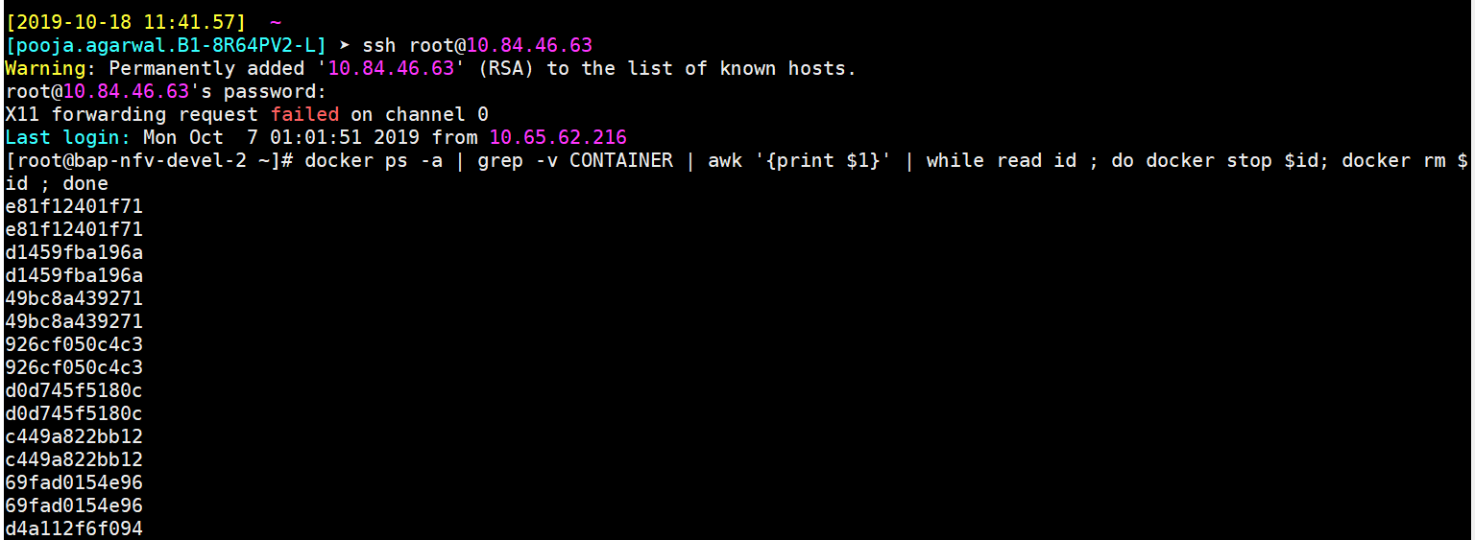

1. Do this only if you want to clean the database :

docker volume rm $(docker volume ls -q)

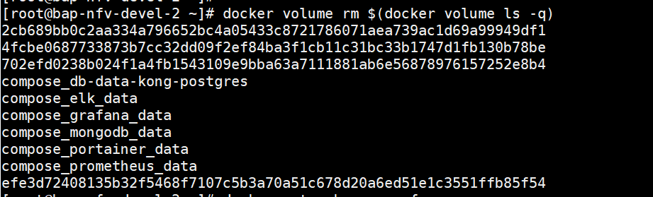

1. remove unused networks by entering below command :

docker network prune –f

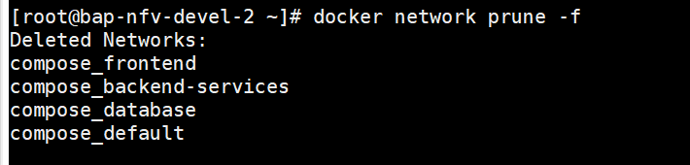

1. use this command to switch to correct node js but this is optional :

nvm use 10

1. Go to cd /opt/bpa
2. Download the BPA zip file like below:

wget <http://wwwin-nccm.cisco.com/build-files/BPA_DOLPHIN_2.2Builds/2.2.000.019/bpa-2.2.000.019.zip>

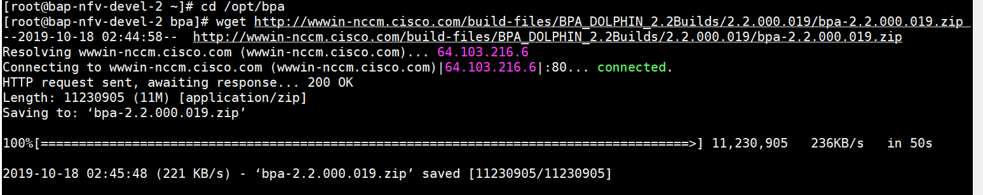

1. Unzip the below file by giving this command :

unzip bpa-2.2.000.019.zip

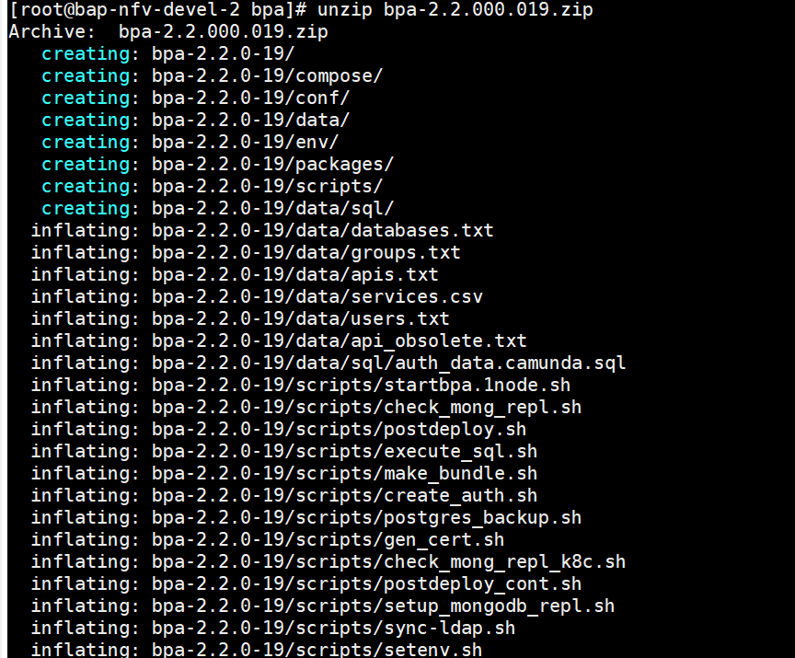

1. After extracting the files , we need to remove the zip file by giving below command :

rm -f \*.zip

1. Go to cd bpa-2.2.0-19
2. Modify the registry path :

sed -i "s|763712334370.dkr.ecr.us-east-1.amazonaws.com|containers.cisco.com|" env/environment.txt

Note : Yellow line is the existing one and blue one is the new line. To find the new line you can go to the build from where you want to copy by giving command cat env/environment.txt and find the registry path and give the same in new build by giving sed command or vi editor command i.e, vi cat env/environment.txt and edit and do :wq! .

1. Modify data/apis.txt by giving command vi data/apis.txt .

If we want to copy the same from other build then go to 18 build by cat data/apis.txt and check the end lines and copy this and open the vi editor in 19 build and copy it.

1. Modify data/services.csv by giving vi data/services.csv .

if we want to copy the same from other build then go to 18 build by cat data/services.txt and check the end lines and copy this and open

1. Modify the db.txt -> vi conf/@cisco-bpa-platform/cs-mongodb/mongo/entry/databases.txt and append your db name
2. Update conf/common/certs/ (3 files)

If you want to copy the same 3 files from 1 build to another then perform below and this is example for 1 cert:

cp bpa-cert.p12 ../../../../bpa-2.2.0-19/conf/common/certs/

1. To check whether its correctly installed and running properly do below:

cd scripts/

./startbpa.1node.sh

tail -f /var/log/bpa.log